ROASTED BROCCOLI WITH PARMESAN CHEESE
SERVES ABOUT 4
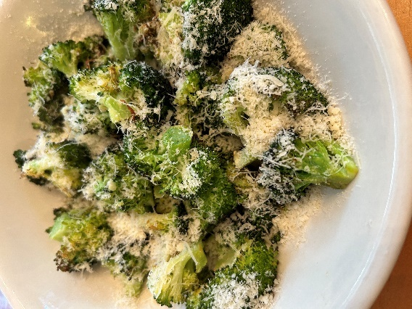
12 oz (about 4 cups) Broccoli, florets, pre-cut, pre-washed
2 Tbsp Olive Oil
1 Tbsp Garlic, minced
1/4 tsp Salt
Pinch Black Pepper
3 Tbsp Parmesan Cheese, grated fine

- Preheat oven to 400°F.
- Place aluminum foil on a baking pan.
- In a mixing bowl add broccoli, olive oil, garlic, salt, and pepper. Mix well.
- Place broccoli on the baking pan.
- Roast broccoli in oven for 10 to 15 minutes or until broccoli edges start to turn golden brown.
- Remove from oven, and place broccoli in serving bowl.
- Sprinkle with parmesan cheese.
- Serve immediately.

